**Final Prototype Test Plan**

To: Professor Pisano

From: Aidan McCall, Jonas Escobar

Team: Team 30: Smart Grid

Date: 4/7/22

Subject: Final Prototype Test Plan

1. **Materials Required**

Hardware

* Smart Grid Test Facility
* PC Computer
* PicoScope
* NI myDAQ
* Banana cables/BNC-Alligator probes
* Electrical outlet

Software

* MATLAB
* MATLAB Signal Processing packages
* Proper DAQ driver softwares
  + NI DAQ mx Elvis/driver software
  + MATLAB Data Acquisition Toolbox
  + MATLAB Data Acquisition Toolbox Support Package for NI-DAQmx Devices
* Final GUI
* Picoscope App
* PicoScope analysis MATLAB script

**2.0 Setup**

2.1 Preparing the model for operation

1. Plug the power strip into the wall. This powers the variac (which starts in the OFF position), the +/- 15 V power supply that powers the sensor boards, the 24 VDC power supply that powers the generators.
2. Make sure that all transmission lines have the top three switches ON and the bottom three switches OFF.
3. Before connecting the model, plug in the 5V 1A power adapter that powers the synchronization circuits. Once plugged in, the LEDs on the MSP30's should light up.
4. Wait a few seconds to let the MSP30's settle, and then turn on the main switch on top, labeled 24V, to bring power to the rest of the model.
5. The variac/reference generator is turned on after.

2.2 Setting up the PicoScope

1. Plug the PicoScope into a computer.
2. Attach the probes to point 1 and point 3 (comparing Generator A to the point it is being added to the grid), according to Figure 1.

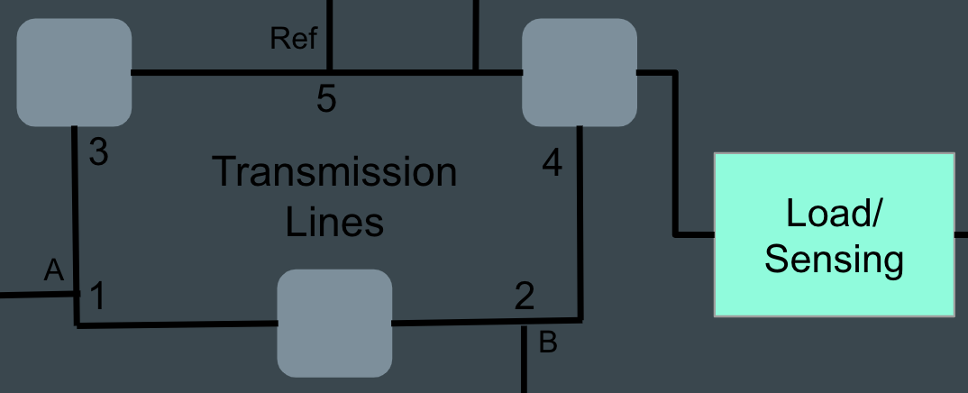

*Figure 1: Basic schematic of the grid*

1. Pulling up the PicoScope 6 application should bring up a live feed with the 60 Hz, 24Vpp wave being visible on the computer, which is coming from the reference variac.

2.3 Activating the generators and synchronizing

1. To turn on a generator, we reset the microcontroller by pressing the button labeled by an arrow for the MSP430 corresponding to that generator. When the button for A is pressed, the generator will begin its rotation and it should now be visible on the PicoScope (from point 1). The peak-to-peak voltage should be about the same as the reference.
2. Next, flip the slide switch on the synchronization circuit for A to the green/on position, which will give additional feedback via the LED. The LED will flicker on and off due to the phase differences between the reference generator voltage and the signal produced by generator A; the two signals are in phase when the LED is dim, and out of phase when it is lit up (i.e. out of phase means there will be a voltage difference across the diode causing it to be lit).
3. The toggle switch (with on/off labels) should be closed (switched to on) at a moment when the two waves are in phase.
4. Closing this will short circuit the two nodes we’re measuring on the PicoScope, so the probe at point 1 should be moved to point 5 to compare generator A to the reference. This way we can check that the peak-to-peak voltage is remaining constant, and if it’s not then the main 24V switch should be switched off, along with the variac, to reset the model and start over. The frequency of generator A should also stabilize to the reference 60Hz, but there may be some instability.
5. These steps will be repeated for generator B, with the PicoScope initially measuring at points 2 and 4 in Figure 1 (moving point 2 to point 5 in step 4). After closing the toggle switch, if voltage amplitudes are remaining constant, then the grid is running properly.

**3.0 Testing Procedure—Measurements through Software**

3.1 PicoScope/waveform visualization

1. Before synchronizing, but with both generator B and the reference generator's on, hook up the probes to point 2 and point 4.
2. After pressing the green play button, two out-of-phase 60 Hz, 24Vpp waveforms should show up on the PicoScope live feed.
3. Two waveforms for each channel input will be visible in the same time domain, allowing a visual comparison of the phase properties at different points on the grid.

3.2 Collecting data from the DAQ

1. Before plugging in any loads, run MATLAB GUI and press “Connect DAQ” to establish connection to the DAQ. This will set up two channels to collect current and voltage.
   1. The DAQ should be connected to the sensor board at this time.
2. Once connection is established, plug the inductive load into the sensor board. And connect the sensor board to the grid. The inductive load is not being powered by the grid.

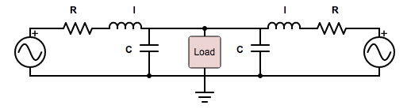

*Figure 2: This schematic shows how the load is connected with the grid. The R, L, and C values are attached to the transmission lines.*

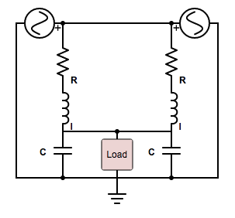

*Figure 3: This schematic shows how the load is connected when making the assumption that the two voltage sources are phase locked.*

1. Press the "Record DAQ" button, which should bring up two waveforms for current and voltage that are approximately sinusoidal.
2. Press the "Phasor Calculation" Button, and the phase, power factor, RMS voltage, and RMS current should appear.
3. Repeat Steps 3 and 4 for various inductor measurements; different arrangements of the inductor PCB switches are outlined in Table 1.
4. Turn the generator input switches to OFF to remove the generators from the grid, leaving the reference switch ON, so that only the reference generator is powering the grid.
5. Repeat Steps 3-5. Compare these measurements to the calculated values in Table 1.

*Table 1:*

| Switch Configuration | Load (H) | Calculated Phase (degrees) |
| --- | --- | --- |
| S1, S8 | 0.1901 | -81.852064 |
| S1, S2, S3, S4, S5, S8 | 0.144 | -79.450134 |
| S1, S4, S6, S8 | 0.1301 | -78.425619 |
| S1, S2, S4, S5, S6, S8 | 0.1028 | -75.713664 |
| S1, S4, S7, S8 | 0.0821 | -72.659963 |

**4.0 Measurable Criteria**

Success for this prototype testing will be measured by the following criteria:

1. Successfully operate the grid entirely on-cart.
2. Successfully start the grid with both generators synchronized and connected to the grid
   1. Synchronization means the 2 generators are added to the grid and no major changes in frequency and Vpp are observed. Note: all three generators will not necessarily be in phase.
3. Successfully connect the PicoScope to the grid, and observe the live feed, using it to synchronize generator B.
4. Successfully connect and collect data from the DAQ, understand what the data is showing about the loads inserted to the grid.
5. Successfully plot voltage, current, and phase data for an inductive load.
   1. Plots should be sinusoidal. Current should lag voltage.
6. When the reference generator is the only power supply, the measured angles should be within 7°.